An emerging industry focused on equine wearable technology and data analytics designed to enhance the safety and performance of horses. Companies like StrideSAFE, Arioneo, and Equimetrics utilize advanced sensors and artificial intelligence to monitor biometric markers, including heart rate, gait symmetry, and respiratory health. These sophisticated tools aim to provide early warning signs of potential injuries and cardiac issues that are often invisible to the human eye or physical touch. Beyond health monitoring, platforms such as Alogo and Stable Analytics offer riders and trainers precise feedback on locomotion and training intensity to refine competitive results. Some organizations also integrate machine learning into breeding decisions by analyzing pedigree and genomic markers to predict future success. Collectively, these innovations represent a scientific shift in equestrian management, prioritizing animal welfare and objective decision-making through 21st-century engineering.
Based on the sources provided, there are several distinct equine wearable technologies, each tailored to specific disciplines ranging from Thoroughbred racing and veterinary care to show jumping and general equine wellness.
Here is a comparison of the different technologies and their specific uses:
1. Injury Prevention and Racing Performance
- StrideSAFE: Designed primarily to eliminate catastrophic injuries in Thoroughbred racehorses. It uses a sensor and GPS system carried during races to record a horse's unique high-speed "fingerprint". When this stride fingerprint changes, it serves as an early warning for caregivers. Using AI algorithms, StrideSAFE can identify early pathology and specific leg, condylar, or sesamoid concerns before a problem occurs on the track.
- Stable Analytics (Equigraph™): Similar to StrideSAFE, Equigraph is a racehorse gait monitoring platform built to quantify injury risk and performance. It relies on biometric sensors to capture biomechanical data that is otherwise invisible to the human eye, providing insights to owners, trainers, and veterinarians.
- Arioneo (EQUIMETRE): Focused on flat and harness racing, this sensor simultaneously collects cardio, locomotion, and GPS data during training. A major focus of EQUIMETRE is detecting "invisible" conditions like atrial fibrillation and tendon injuries. It features an advanced automated ECG screening tool powered by artificial intelligence to detect cardiac rhythm abnormalities under real-world conditions.
2. Clinical and Veterinary Care
- Equimetrics (V-PRO & S-PRO): Equimetrics offers specialized tools for both training and clinical environments.
  - V-PRO is tailored for equine hospitals and veterinarians to provide 24/7 remote clinical monitoring of vitals. It includes an anatomically designed harness that captures integrated ECG anywhere (in the stall or on the gallops) and features a built-in microchip scanner for easy horse identification.
  - S-PRO is their sports performance model, optimizing training by tracking speed, stride cadence, GPS terrain, and post-exercise heart rate recovery.
3. Show Jumping and Equestrian Sports
- Alogo (MOVE PRO): Founded by a former professional show jumper, Alogo aims to modernize equestrian sports. The MOVE PRO sensor acts as an innovative training tool for riders and coaches to track performance. Uniquely, it is also used to make live equestrian events more attractive to the public by providing advanced visual statistics during competitions. It additionally aids in injury prevention by detecting minor changes in locomotion.
4. General Equine Wellness and Consumer Tracking
- Garmin Blaze™: This is a consumer-friendly equine wellness system that easily attaches to a horse using a durable, washable neoprene tail wrap. It uses an optical sensor to track heart rate, strides, gait, and changes in skin temperature. Unlike the specialized clinical and racing tools, Garmin Blaze is designed to sync seamlessly with the user's smartphone or Garmin smartwatch. It also includes a unique "Heat Score" feature, which combines air temperature and humidity to guide the rider on the safety of exercising the horse in current weather conditions.

E-Trakka is a state-of-the-art equine fitness monitoring platform designed to provide trainers with a comprehensive, quantitative analysis of a racehorse's performance, health, and potential. It achieves this by combining global positioning system (GPS) speed tracking with cardiac telemetry.
Here is an overall brief of the E-Trakka system based on the provided sources:
History and Development The concept was conceived in 1992 by Andrew Stuart, a former jockey and assistant trainer for the legendary Bart Cummings. Stuart recognized that measuring heart rate in isolation was not enough; to get a true diagnostic picture, cardiac exertion had to be directly correlated with the horse's speed and mechanical workload. After years of development and field testing, the first commercial E-Trakka unit was released in 2006. Today, the system has logged over 200,000 training sessions, creating a massive database of equine athletic benchmarks.
Hardware and Technology The current flagship model, the E-Trakka XV4, is housed entirely within a durable, military-standard saddle blanket. Unlike older models that required external antennas and exposed wiring, the XV4 is a fully integrated, cable-free system.
- Sensors: It features a 24-bit digital ECG, multi-constellation GPS, and built-in electrodes to capture highly accurate heart rate and velocity data.
- Automation: Designed for the high-pressure environment of a training stable, the blanket automatically recognizes a workout, records the data, and uploads it in real-time to a secure Microsoft Azure cloud server via a 4G cellular connection. It requires absolutely zero manual interaction or downloading by the rider or trainer.
Key Metrics and Methodology E-Trakka goes beyond basic tracking by using proprietary mathematical modeling to analyze a horse's physical capabilities:
- Fitness Score: The software correlates kinetic output with cardiovascular strain, calculating a "Fitness Score" determined by dividing the horse's velocity by its maximum heart rate. Elite horses typically score around 62 to 63, indicating high speeds with low cardiac strain.
- SL50 (Stride Length): E-Trakka captures a horse's stride length specifically when traveling at 50 km/h (about 31 mph). Because horses experience massive deceleration forces when their front feet strike the ground at high speeds, evaluating their stride at this specific velocity is highly diagnostic of their biomechanical efficiency and natural ability.
- The "Tanks" Concept: E-Trakka utilizes the "2020 Racehorse Training methodology," which models a horse's "engine" into an anaerobic tank (speed/sprinting) and an aerobic tank (endurance/recovery). Understanding the ratio of these tanks helps trainers pinpoint a horse's exact class and optimal racing distance.
Use Cases and Benefits Trainers use E-Trakka to systematically eliminate guesswork and reduce "wastage" in the industry. It allows users to:
- Identify whether a horse is a natural sprinter or stayer.
- Tailor individual training regimens and objectively track fitness progression.
- Detect early signs of lameness, illness, or cardiovascular abnormalities before they become clinically obvious.
Commercial Details and Adoption A single XV4 unit costs approximately $3,600 AUD (or ~$3,000 USD) as a base price. After an initial period, there is a recurring software and cellular subscription fee of $49 AUD (or ~$35 USD) per month per unit.
The system is highly regarded and has been adopted by leading professional trainers in Australia and abroad, including Chris Waller, Edward Cummings, and Bjorn Baker. Over the years, E-Trakka has been instrumental in monitoring elite champions such as Mirror Mirror (its first major success in 2006), Yes Yes Yes (The Everest winner), Duais (Queensland Oaks winner), and the dual Eclipse Award-winning sprinter Runhappy.
Greg Fox
E-Trakka Arrives in America--And With It, An Enthusiastic Disciple of Data
This article profiles Dr. Greg Fox, a veterinarian and former horse trainer who is introducing the E-Trakka fitness monitoring system to the American Thoroughbred racing industry. The text describes how this Australian-developed technology utilizes specialized saddle pads to capture real-time biometric data, including heart rate and stride length, allowing for a more scientific approach to equine conditioning and health. By bridging the gap between traditional horsemanship and dynamic exercise physiology, Fox aims to help trainers validate their instincts and prevent overtraining through objective analytics. Ultimately, the piece serves to highlight the growing role of data-driven diagnostics in optimizing the performance and welfare of elite racing athletes.

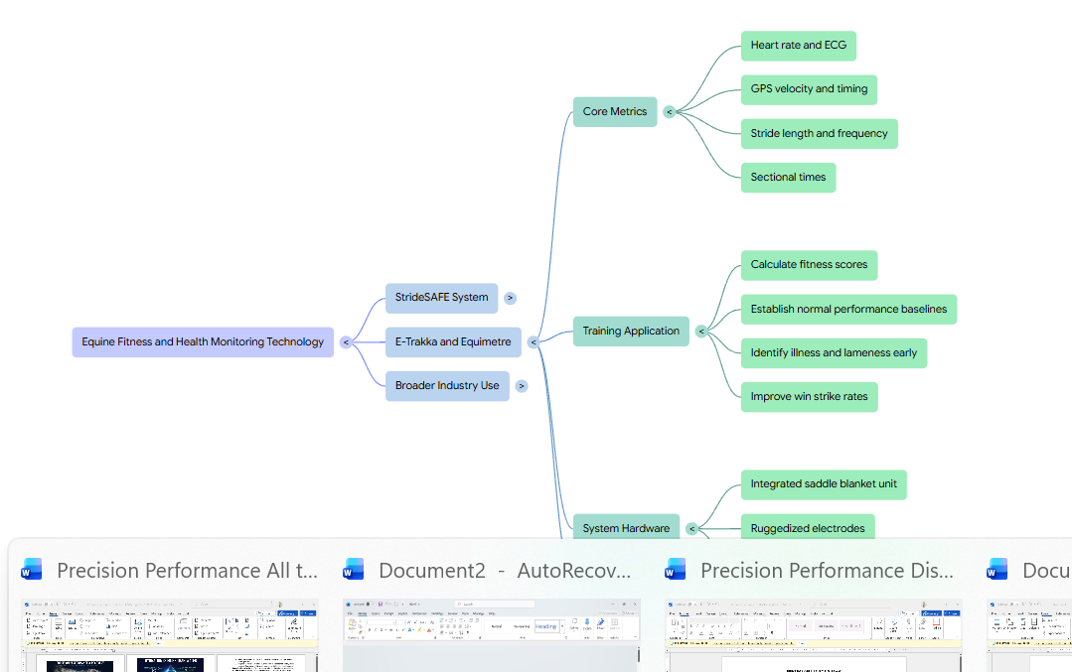
EQUIMETRICS Smart Equine Monitoring | Equimetrics – Intelligent monitoring of horse performance and health.

focused on the evolving the remote monitoring hardware and communications protocols.
His background is in Product Design and Electronics Engineering.
gathering and analysing biometric data from horses in the ultra-completive world of elite thoroughbred racing.
In this time he has innovated various methods of determining stress levels in stabled horses and developed tailored assessment tools to maximize effectiveness of training protocols.
Intelligent data is key to maximising performance and protecting equine health.
Trusted by leading training facilities and equine clinics worldwide, Equimetrics’ patented technology delivers powerful insights that support the performance, wellbeing, and long-term care of horses like never before.
S-PRO combines comfort with cutting-edge sensor technology. Simply replace your regular saddle pad with the S-PRO PAD, scan your horse’s microchip using the S-PRO Sensor, and place it in the holster—it’s that easy. S-PRO captures speed, stride, and heart rate, while also tracking route and terrain for detailed post-ride analysis. With onboard heart monitoring, it also records post-exercise recovery, offering insights into effort, fitness, and overall performance.

